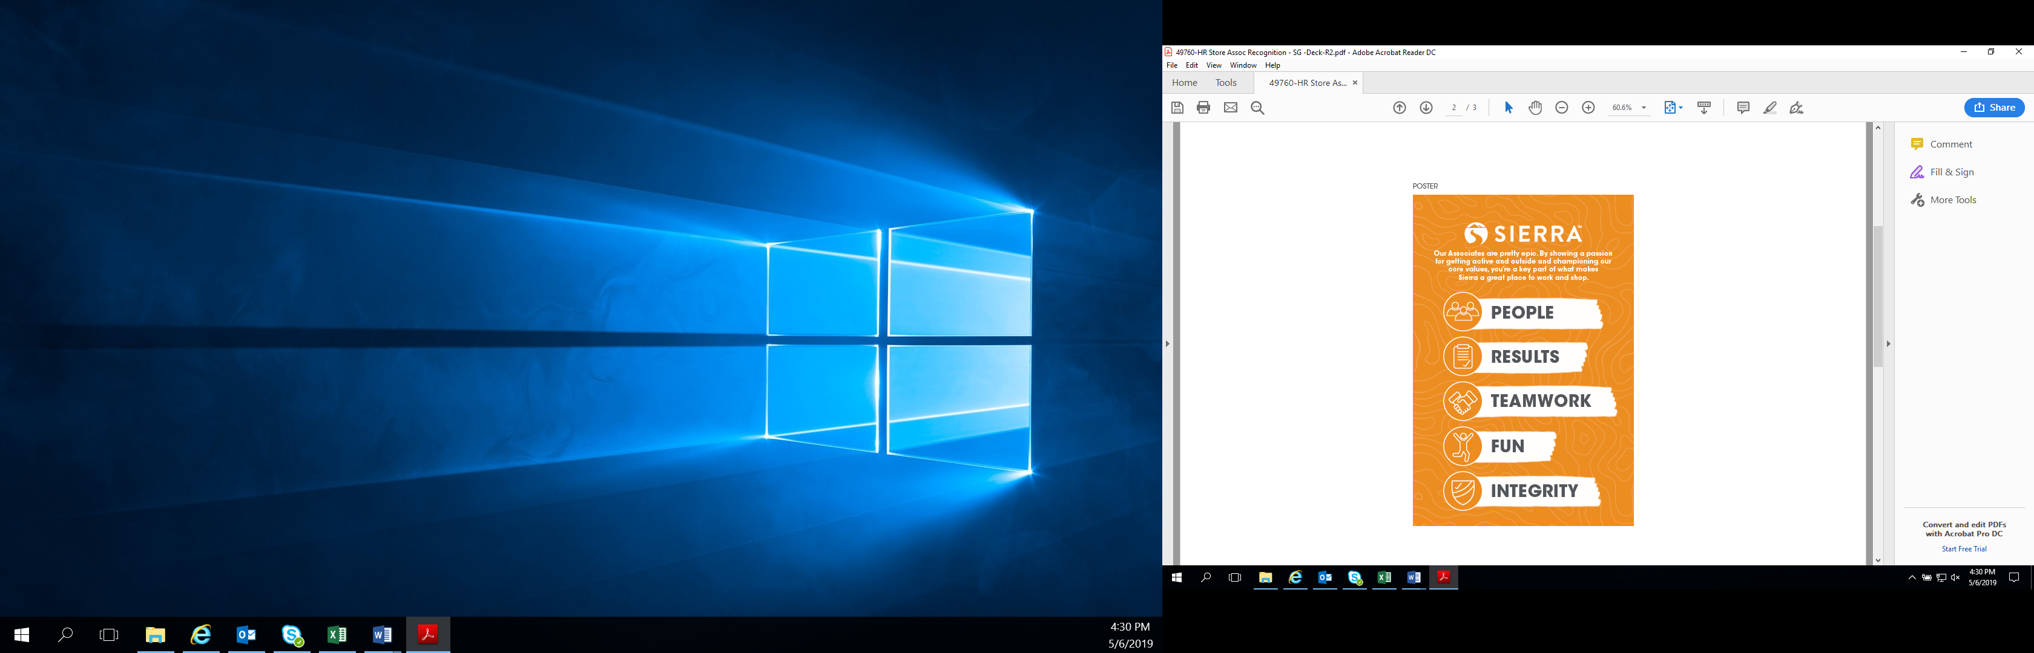

S.O.A.R Winners for September 2023
Congratulations! Thanks for all that you do!
Trevor- $20
Carrie- $10
Kindel- $10

